Information and Communication Technology
Name: Joseph Tierney | Course: Computer Science 1B
Module: Communications (G20001) | Tutor: Ulrike McMahon
Date of Issue: 23/09/14 | Submission Date: 1/10/2014
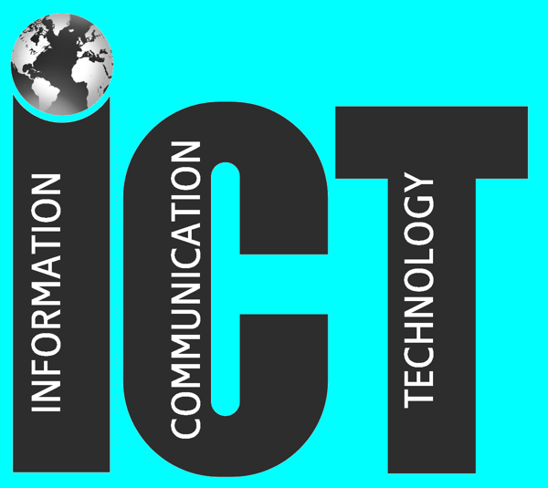

Contents
- Introduction
- Advantages of ICT in a Business
- Disadvantages of ICT in a Business
- Advantages of ICT in Society
- Disadvantages of ICT in Society
- Recomendations and Conclusion
- References

1 Introduction
Information and Communication Technology, commonly known as “ICT”, refers to technologies that provide access to information through means of telecommunications.
ICT has alternated the way in which we work, shop and spend our free time. While it may have improved life in a variety of different ways, we need to wary about how we use it. Spending hours upon hours at a computer can have a significance on our health and safety, and it's very easy to spend a lot of money without thinking. This report will examine the advantages and disadvantages of using Information and Communication Technology in businesses and in society in general, and it will draw recommendations regarding the disadvantages that are brought up.

2 Advantages of ICT in Businesses
As businesses attempt to keep being competitive in the global markets, there are many advantages introducing ICT into the workplace. Productivity will see a huge up rise in working environments. With new technology being implemented into working environments, productivity should see a huge growth, as certain, if not all, activities will see a significant boost in completion.
Along with productivity, quality and accuracy will see a huge improvement with the addition of ICT in the workplace. Human error plays a huge part in organizations, but machines and technology will be able to replace some of the workload and tasks that humans need to do, as machines are suited to produce the same standard of product all the time, which in turn will lower the rate of human error.
Introducing ICT into a business can also improve communications with that business, and to an external extent, even its customers. Through the use of new technology such as email and video conference calls through Skype, communications between local branches or even between countries will be massively improved. Instead of using flights and accommodation, holding a video conference can and will save money. Thanks to ICT, the world's economy has become a single interdependent system. With this, we can share information readily and swiftly, but we can also bridge the cultural gap. With ICT, countries like Ireland and Japan, which are separated by distance and by language are able to share ideas, thoughts and information with each other without any trouble.

3 Disadvantages of ICT in Businesses
However, with advantages come certain disadvantages.
Financially, if a business were to buy brand new equipment, the equipment is normally expensive, and maintenance costs for multiple computers will be extremely high, causing the business to lose money in the process. Machinery and equipment can also undergo breakdowns, which in turn affects the production and continuation of work in the business.
ICT can replace some employees’ jobs, which can demoralize the staff and their motivation may suffer with this. As a result of this de-skilling of their job, workers can feel they are vulnerable to becoming redundant.
The internet is crowded with distractions, which may see employees prefer to play games, browse the internet and update their social network accounts, or reply to personal emails and instant messages rather than get on with and finish their work. However, employers are apprehensive to this and usually block access to certain websites. Sometimes these restrictions are toned down during lunchtime and outside of working hours.

4 Advantages of ICT in Society
As with businesses, introducing Information and Communication Technology to society has a wide range of advantages.
Technology has altered the way society shops, and the way that shops and merchants operate. The range of products available online has grown, and it continues to grow and people are, to a greater extent, more confident buying products online. On the internet, almost anything can be purchased, some of these things include furniture, CDs, DVDs and electronics.
Some companies only operate online and do not have high street stores. It's cost effective for the company, as it keeps costs down and ultimately results in cheaper prices for customers.
With online stores rising, it has created new jobs for people who build, design and run websites.
Shopping online is extremely convenient, as it can be done at home, at work, during lunchtime or even on the go using a smartphone. There's also a greater variety of products available and makes it easier to compare prices and find the better deal. Shopping online is also accessible to those with a disability that limits what shops they can go into.
Information and Communication Technology has also changed the way in which people spend their free time. Society itself has entered the digital age, as people no longer see the need for the physical copy of a CD, DVD or book. Instead, people prefer to read the news online instead of spending money on buying a newspaper or a magazine.
ICT has allowed society to download and read books on tablets, phones and e-readers instead of paper books. Streaming music and movies has grown in popularity. It has allowed the use of downloading and streaming music or films from the internet, which makes it convenient. As well as this, downloading games and watching TV after it's aired has become more popular due to ICT.
Information and Communication Technology has also allowed society to keep in touch with people in other cities, and even people in other countries, resulting in less isolation. With the use of Facebook, Twitter, Skype, and other instant messaging services, people can maintain a long distance friendship or relationship without having to spend money on flights and accommodation. We also have access to information when we want it, and how we want it.

5 Disadvantages of ICT in Society
With society moving towards digital downloads, there has been a lot of concern for the industry, and it's owners. Today, it's easier now than it even was to share a book, music or movies with family, friends and even strangers. This allows friends, family and strangers to watch or listen to the digital downloads without ever having to pay for it, which in turns, breaks copyright laws. As a result of the piracy, bands, authors and production companies make less money for their hard work and dedication. There may be less incentive for artists and authors to bother writing books, songs or albums anymore, causing everyone to lose out.
As with the digital download age, there are some concerns with shopping online.
There are many problems that come with shopping online. Some people are uncomfortable entering their credit card details online, as they can be easily fooled into thinking that the website they are buying from is a legit site, which results in all of their money being robbed.
The items may get damaged during transport, depending on what it is, may cause it to no longer work, or be unusable. Physically, a customer is unable to examine what it is they are buying, and often get the complete opposite of what the picture of the product show.
While ICT can help us keep in touch with long distance friends and family, it can also cause isolation. Kids, teenagers, and even some adults spend long hours on a computer, not interacting socially and suffer a loss of real human contact. It can also result in the loss of jobs, as adults become addicted to sitting around on the computer all day and refuse to do any work whatsoever.

6 Recommendations and Conclusion
It is clear, that while Information and Communication Technology has a wide range of advantages, it also contains a lot of disadvantages. While ICT certainly has a place in the future, society itself must have a healthy balance between being social and using ICT in their every day life, as too much of one can play a major factor on ones life and health. Many companies are using ICT, and creating jobs for programmers and web site designers. Furthermore, it is worth noting that the IT industry is one of the most steady jobs in the world, and hasn't been affected by the global recession, and with the increase of programs, games, web sites that need to be developed, the future of the IT industry is going to see a surge in employment.

7 References
Storify.com. 2014.
Some of the Advantages and Disadvantages of Communications Technology ICT. [ONLINE]
Available at: https://storify.com/RoryP1/some-of-the-advantages-and-disadvantages-of-commun.
[Accessed 23 September 14].

BBC.co.uk. 2014.
BC - Higher Bitesize Business Management - Business information and ICT. [ONLINE]
Available at: http://www.bbc.co.uk/bitesize/higher/business_management/business_enterprise/business_information_ict/revision/6/.
[Accessed 01 October 14].

Chron.com. 2014.
Advantages & Disadvantages of Information & Communication Technology. [ONLINE]
Available at:http://smallbusiness.chron.com/advantages-disadvantages-information-communication-technology-66948.html.
[Accessed 29 September 14].

